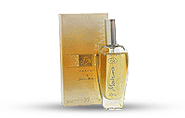
MINŐSÉGI PARFÜMÖK HIHETETLEN ÁRON!!!
3.500 Ft/üveg

Női illatok 30ml
1 Davidoff Cool Water
2 Christian Dior Dune
5 Gucci Rush
6 Elizabeth Arden Green Tea
7 Giorgio Armani Acqua di Gio
8 Kenzo L'eau par
9 Naomi Campbell NaoMagic
10 Christian Dior J'Adore
11 Cacharel Noa
14 Hugo Boss Deep Red
16 Gabriela Sabatini Muelhens
18 Chanel Coco Mademoiselle
21 Chanel No. 5
23 Cacharel Amor Amor
24 Kenzo Jungle Elephant
25 Hugo Boss Hugo Woman
26 Naomi Campbell Naomi
29 Lancome Miracle
30 Valentino Very V. Femme
31 Hugo Boss Intense
32 Thierry Mugler Angel
33 Dolce & Gabbana Light Blue
34 Chanel Chance
35 Giorgio Armani Sensi
36 Paco Rabanne Ultraviolet
37 Jennifer Lopez Glow by J.Lo
38 Givenchy Very Irresistible
39 Celine Dion Celine Dion
40 Burberry Weekend for Women
44 Lancome O'oui
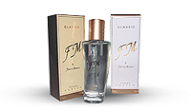
46 Yves Saint Laurent In Love Again

47 Elizabeth Arden 5-th Avenue
48 Calvin Klein Eternity Moment
49 Calvin Klein Truth
70 Lancome Tresor
71 Gucci Envy Me
72 Lacoste Touch of Pink
73 Davidoff Echo Woman
74 Giorgio Armani Mania
75 Yves Saint Laurent Opium
76 Christian Dior Dolce Vita
77 Christian Dior Pure Poison
78 Trussardi Skin
79 Burberry Week End Women
90 Tommy Hilfiger 5500ft
True Star (75ml)
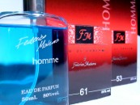
91 Celine Dion Parfum Notes 5500ft

Férfi illatok 50ml 3500ft
51 Davidoff Echo
52 Hugo Boss Boss
53 Davidoff Cool Water
54 Hugo Boss Hugo
56 Christian Dior Fahrenheit
57 Lacoste Lacoste
58 Chanel Allure
59 Kenzo Kenzo Frais
61 Giorgio Armani Emporio
63 Adidas Adidas Black
64 Giorgio Armani Black Code
65 JOOP! JOOP! Homme
66 Christian Dior Higher
67 Chanel Allure Homme Sport
68 Dolce & Gabbana Men
69 Ralph Lauren Polo Sport Blue
92 Cerruti Cerruti Si (100ml) 6000ft
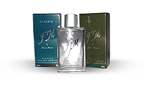
93 Azzaro Chrome (100ml) 6000ft

